**ABM – Week 9 – Seminar – LVL3**

**Purpose**

This task you will introduce you to a means of coding purposeful agent movement, allowing turtles to navigate effectively to a location of interest, while avoiding obstacles in their path. The extension tasks will incorporate ideas of differential knowledge between agents and how this can affect dynamics.

**Model**

Open the model evacuation_model_baseline.nlogo. This model represents concertgoers (pink) and staff members (cyan) milling around a concert venue.

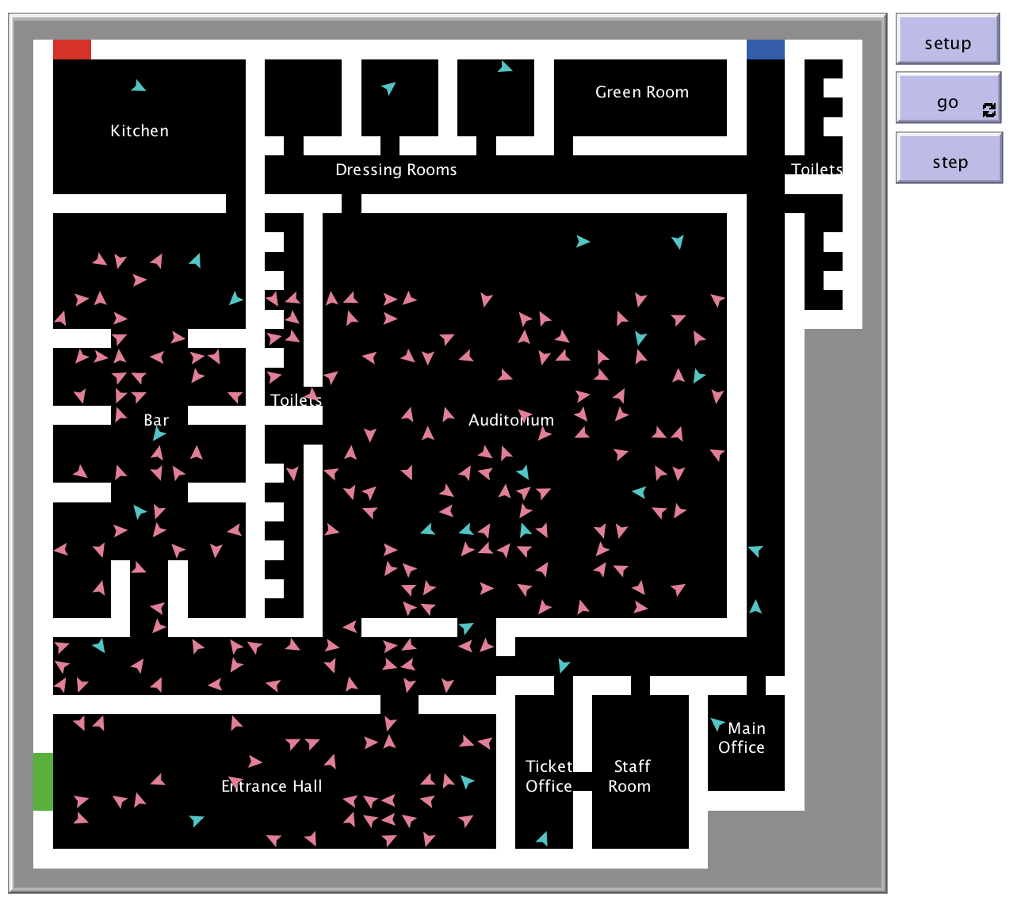

In the tasks below, you will simulate the emergency evacuation of agents from the venue via the three exits (green, blue and red).

Look at the ‘move’ procedure in the code, which controls agent movement.

* What are the restrictions on the movement of concertgoers and staff members and what are the effects of these restrictions?
* Why do you think the primitive ‘carefully’ used in this procedure?

Running the procedure show-staffonly in the Command Centre in the interface should help you understand the model more thoroughly.

**Task**

Simulate an evacuation alarm going off after a certain number of ticks. Change the move procedure so that all agents head to the green exit (Exit 1) when the alarm sounds. Remove agents from the model when they reach the exit. Create a plot to monitor the proportion of concertgoers and staff members who have successfully evacuated the building as time passes.

To allow the agents to navigate to the exit successfully, you will need to give each patch a variable stating its distance from the exit, *accounting for the internal structure of the building*. To set this variable correctly, you will need to write a procedure that starts by considering the patches in Exit 1 and iteratively sets the distance of adjacent patches inside the building until all internal patches have a distance variable assigned.

**Extensions**

* Alter the code so that agents head to the nearest exit – I (green), 2 (blue) or 3 (red), rather than all heading to the same one. Add a plot to monitor the number of individuals who have been evacuated by each exit.
* Alter the code so that agents may only have knowledge of certain exits and head towards the nearest exit that they know of, even if another exit may be closer.